First steps in pyspread


by Martin Manns 2011

Table of Contents
1 About this document 3
2 What is pyspread? 3
3 Current limitations 3
4 Installation 4
4.1 Requirements 4
4.2 Installation from source 4
4.3 Installation from .deb package 4
5 The pyspread workplace 4
5.1 Starting and quitting pyspread 4
5.2 Pyspread main window 5
5.3 Using the menus 5
5.4 Using dialogs 5
5.5 Basic preferences 6
6 Basic concepts 6
6.1 3D grid 6
6.2 Everything is accessible 6
6.3 Python code as cell language 6
6.4 Trust based security 7
7 Common spreadsheet tasks 7
7.1 Moving in the spreadsheet 7
Switching tables 7
7.2 Entering data 7
Changing and deleting cell content 7
7.3 Selecting cells 8
7.4 Copy and Paste operations 8
7.5 Undoing work steps 8
7.6 Creating an empty spreadsheet 8
7.7 Loading and saving a spreadsheet 9
7.8 CSV data import and export 10
7.9 Printing 10
7.10 Finding and replacing 10
7.11 Sorting 11
8 Working with formulas 11
8.1 Grid cells expect Python expressions 11
8.2 Variable assignment 11
8.3 Result strings in the grid 12
8.4 Absolute cell access 12
8.5 Relative cell access 12
8.6 Frozen cells 12
8.7 Macros 12
8.8 Module import 12
8.9 Cyclic references 12
8.10 Result stability 12
8.11 Error handling 12
9 Using help 13
9.1 Tutorial access 13
9.2 In-code documentation 13
10 Grid layout 13
10.1 Formatting basics 13
10.2 Fonts and font attributes 13
10.3 Text alignment, justification and rotation 13
10.4 Border and background color 13
10.5 Row height and column width 13
10.6 Insertion and deletion of rows and columns 13
11 pyspread and security 13
11.1 More than your average spreadsheet 13
11.2 Dangers of using pyspread 13
11.3 Security benefits and risks from save file signatures 13
12 Charts 13
12.1 Charts with matplotlib 13
12.2 Charts with rpy2 13
12.3 Charts with pychart 13
13 Advanced topics 13
13.1 Drawing cell content with a cell formula 13
13.2 Handling large amounts of data 13
13.3 Substituting pivot tables 13

About this document
This document shall provide a quick overview over pyspread.

What is pyspread?
Pyspread is a spreadsheet application that computes Python expressions in its cells. It is written in the programming language Python.
The core mission of pyspread is to make coding in a spreadsheet as pythonic as possible. Cell functions that are known from conventional spreadsheets such as Excel™, gnumeric or OpenOffice.org Calc are not supported. Instead Python expressions are entered into the spreadsheet cells. Each cell returns a Python object. These objects can represent anything including lists or matrices.
At least basic knowledge of Python is required to effectively use pyspread.
Pyspread provides a three dimensional grid that can comprise millions of rows, columns and tables. However currently, a dictionary is used for storing all grid data. Therefore, tables with many filled cells may require considerable amounts of RAM.

Current limitations
External libraries such as matplotlib that set states in several steps may be unusable or hard to use because cell execution order is not guaranteed. They should be used from within a macro.
- There is no chart creation GUI interface.
- There is no cell auto-fill functionality.
- Cell execution cannot be interrupted or terminated if slow and therefore may block pyspread.
- Toolbar positions are not saved in the config file.
- Cycle detection can be tricked. Cell results can be unstable if cyclic dependencies are introduced.
- Cell attributes can only be set in the toolbar but not in the menubar

Installation

Requirements
Linux and *nix platforms with GTK+ support.
Dependencies
- Python >=2.4 <3.0
- numpy >=1.1.0
- wxPython >=2.8.10.1 (unicode version required).
- PyMe >=0.8.1

Highly recommended for full functionality
- gmpy >=1.1.0
- rpy >=1.0.3.

Installation from source
- Untar the source package into a directory of your choice:
tar xzvf pyspread-<version number>.tar.gz
- Run:
python setup.py install

Installation from .deb package
Download the deb package and type
dpkg -i <package name>

The pyspread workplace

Starting and quitting pyspread
Type
$ pyspread
from the command prompt.
You can quit pyspread by closing the main window or by selecting File → Quit from the menu.

Pyspread main window
The main window consists of the title bar, the menu, toolbars, the entry line, the table selector, the grid and a status bar (see Figure 1).
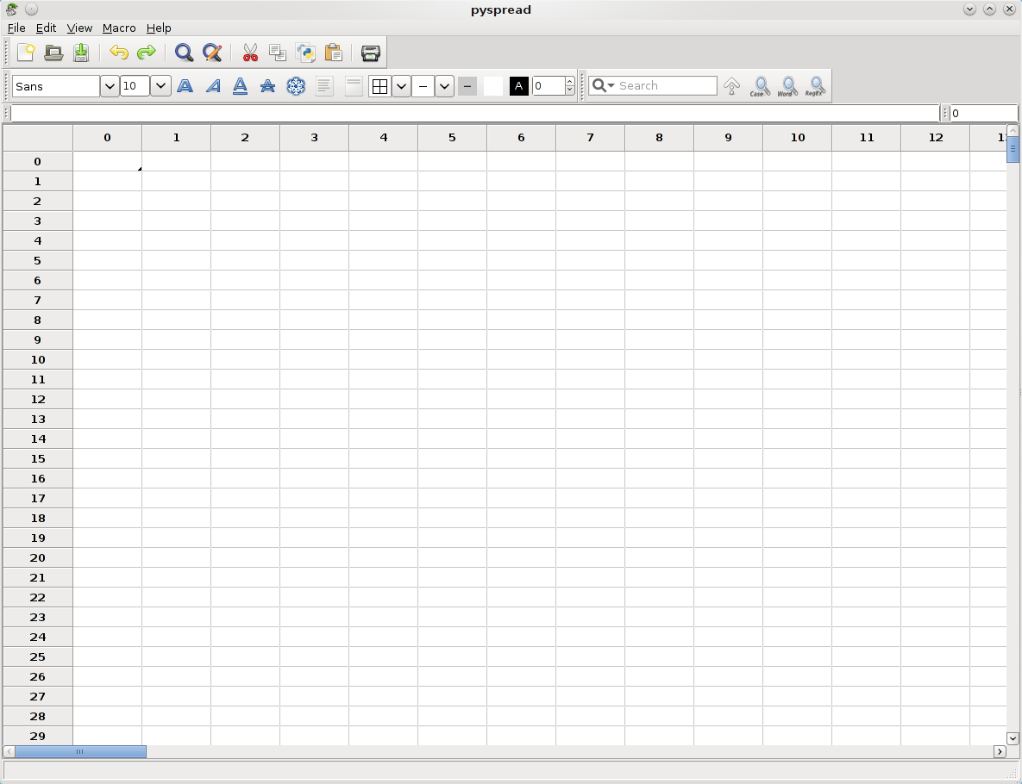Figure 1: Pyspread main window

Using the menus
There are two menus in pyspread: The main menu and the context menu. The main menu is visible above the tool bars. The context menu is accessible by right-clicking on the grid.
The main menu makes all pyspread functions but cell formatting available. The latter is only available via tool bar and not yet integrated into the main menu.
All options in the context menu are available from the main menu as well.

Using dialogs
Pyspread uses both modal and non-modal dialogs. Modal dialogs block further usage of pyspread while open while non-modal dialogs allow continuing the usage of the main program. Non modal dialogs are:
- The Search & Replace dialog

Basic preferences
Pyspread stores its configuration in a file ~/.pyspreadrc
This file is created when first starting pyspread. Removing it resets configuration.
Initial configuration can be viewed in pyspread/src/config.py

Basic concepts

3D grid
Pyspread features only one grid at a time. However, this grid is 3D, i. e. there are rows, columns and tables in the grid. The main difference to common spreadsheets is that each dimension is considered equal. Therefore, deleting a row deletes this row in all(!) tables.
There are no sheets at the moment, in which row operations do not affect other tabs. Sheet functionality may become part of future releases.

Everything is accessible
All parts of pyspread are written in Python. Therefore all objects can be accessed from within each cell. This is also the case for external modules.
There are 4 convenient “magic” objects, which are merely syntactic sugar: S, X, Y and Z.
S is the grid data object. It is ultimately based on a dict. However, it consists of several layers on top. When indexing or slicing, it behaves similarly to a 3D numpy-array that returns result objects. When calling it (like a function) with a 3 tuple, it returns the cell code.
X, Y and Z represent the current cell coordinates. When copied to another cell, these coordinates change accordingly. This approach allows relative addressing by adding the relative coordinates to X, Y or Z. Therefore, no special relative addressing methods are needed.
External modules are accessible from each cell. Unfortunately, Python’s convenient import syntax
from xx import yy
is no expression. Therefore, the expression
xx = __import__(“xx”)
has to be used.

Python code as cell language
Pyspread uses Python expressions in each cell. This is similar to typing expressions into the Python shell. However, there is no guaranteed execution order. Furthermore, all results are accessible from each other cell.
Variable assignment works only once in each cell. Therefore
a = b = 2
is invalid in pyspread.

Trust based security
Since Python expressions are evaluated in pyspread, a spreadsheet is as powerful as any program. Therefore, it could harm the system or even send confidential data to third persons over the Internet. Even though this is basically the case for all office applications, the easy access to such behavior makes precautions necessary. The idea in pyspread is that you – the user – are trustworthy and no-one else. If you save a file then a signature is saved with it (suffix .pys.sig). Only you can re-open the file directly. If anyone else opens the file, it is displayed in safe mode, i. e. each cell displays the cell code and no cell code is evaluated. The user can approve the file, after which the cell code is evaluated. When the user then saves the file, it is newly signed. Then it can be re-opened without safe mode.
An intended side-effect of this approach is that when two users open the file on a network share, the signature file of one user is not recognized by the other, which makes re-approval necessary.
Technically, signing is done with GPG. When starting pyspread the first time as a user, a new GPG key pair (name pyspred_<user_id>) is created, which is then used for signing files.

Common spreadsheet tasks

Moving in the spreadsheet
Movement in the grid can be achieved by:
- Scrolling with the scrollbars
- Selecting “View → Go to cell” from the main menu
- Moving the grid cursor with the arrow keys
- Clicking on a cell
- Accessing the grid API (advanced)
This covers row and column movement.
Table movement is described in the next paragraph

Switching tables
Tables can be switched by changing the number in the table switch textbox that is situated right of the entry line directly above the grid.
This can be achieved by either typing in a table number or by moving the mouse over the table switch textbox and then scrolling with the mouse wheel.

Entering data
Data is entered into the grid cells by selecting a cell and then typing the text. The text can also be entered into the text-entry line. The text is accepted and evaluated when <Enter> is pressed or when a new cell is selected. Note that <Enter> does not work from withing the text entry line.

Changing and deleting cell content
In order to change cell content double-click on the cell or select the cell and edit the text in the entry line.
A cell can be deleted by selecting it and pressing <Del>. This also works for selections.

Selecting cells
Cells can be selected by the following actions:
- Keeping the left mouse button pressed while over cells selects a block
- Pressing <Ctrl> when left-clicking on cells selects these cells individually
- Clicking on row or column labels selects all cells of a row or column
- Clocking on the top-left label of the grid or pressing <Ctrl> + A selects all grid cells of the current table
Only cells of the current table can be selected at any time. Switching tables switches cell selections to the new table, i. e. the same cells in the new table are selected and no cells of the old table are selected.

Copy and Paste operations
Copying and pasting can be done from within cells, which copies the text.
Furthermore, cells can be copied and pasted. If more than one cell is selected, the copied set consists of the bounding box of the marked cells, i. e. the smallest box, in which all cells are situated. Cells that are not selected in that box are copied as if they were empty. When pasting cells, these empty cells are pasted as well as the filled cells. That means that an unselected cell in a marked area will be pasted as empty cell.
The format of cells that are copied is tab separated Unicode.
When copying cells with <Ctrl> + C, the cell code is copied. There is a second type of copy <Shift> + <Ctrl> + C, which copies string representation of the results. This is useful, if for exapmle the result shall be copied into an external application.

Undoing work steps
Pyspread features undo and redo functions for most user actions. Exceptions are:
- Loading a file (empties undo list)
- Saving a file (ignored)
- Approving a file (ignored)
The undo list is limited. The limit can be set in the configuration file .pyspreadrc in the variable max_unredo.

Creating an empty spreadsheet
An empty spreadsheet can be created by File → New.
A Dialog pops up, in which the size of the new spreadsheet grid can be entered. Note that even though sizes of several million rows or columns are possible, there is a limit that is imposed by wx.Python. Therefore, grids with more than 80 million rows and 30 million columns may show problems and instabilities.
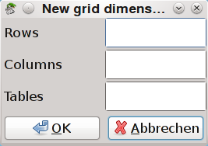
Figure 2: Grid dimension dialog

Loading and saving a spreadsheet
Loading and saving a spreadsheet from and to disk can be initiated with File → Open and
File → Save. Opening a file expects a file with the extension .pys. The file format is pyspread specific.
Since pyspread files are ultimately Python programs, an opened file is stored in safe mode if it has not been previously signed by the current user on the current system. Safe mode means that the cell content is loaded and displayed in the grid. However, it is not executed, so that 2+2 remains 2+2 and is not computed into 4. You can leave safe mode with File → Approve.
When a file is saved, a signature is created in an additional file with the suffix .pys.sig. The signature is a PGP signature. When pyspread is started the first time for a user, a pgp key pair is crreated for the user pyspread_<user-id>. This key pair is used for signing pyspread save files. A correct signature file lets pyspread open a file without going into safe mode.
The pys file format has changed in version 0.2.0. It now is a bzip2-ed Text file with the following structure:
[Pyspread save file version]
0.1
[shape]
1000 100 3
[grid]
7 22 0 'Testcode1'
8 9 0 'Testcode2'
[attributes]
[] [] [] [] [(0, 0)] 0 'textfont' u'URW Chancery L'
[] [] [] [] [(0, 0)] 0 'pointsize' 20
[row_heights]
0 0 56.0
7 0 25.0
[col_widths]
0 0 80.0
[macros]
Macro text

CSV data import and export
Pyspread can import and export csv data for interacting with other applications. However, grid formatting is lost this way.
With File → Import, a csv file can be imported. There are two import filters.
“Tab-delimited text file” is fast but does not handle ill-formed data or special formats well. As the name suggests, only Tab delimited values are allowed.
The other filter “Csv file” opens the CSV file import dialog. In this dialog, CSV import options can be set. Furthermore, target Python types can be specified, so that import of dates becomes possible. The grid of the import dialog only shows the first few rows of the csv files in order to give an impression how import data will look like in pyspread.
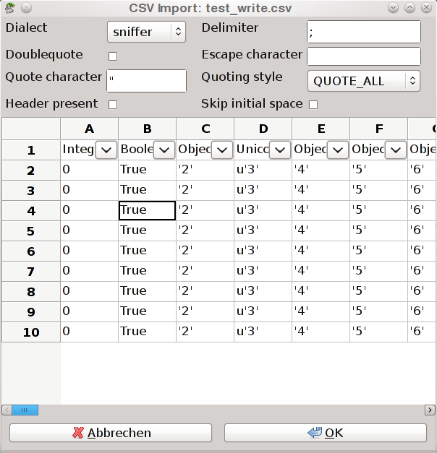Figure 3: CSV file import dialog
Importing a file always activates safe mode (when no signature file is created manually) because code in the CSV file may be harmful.

Printing
When selecting File → Print, the grid is printed. When there is no selection, the visible part of the grid is printed. Otherwise, the selected part of the grid is printed. Beware of selecting huge parts of the grid because this may lock up pyspread.
Printing is always done on one page. The grid is shrunk to fit.

Finding and replacing
Cell code and cell results can be searched with <Ctrl> + F or using the menu with Edit → Find. The focus changes to the search toolbar, in which search queries can be entered. Pyspread allows searching contained text, word-wise contained text and regular expressions, which can be toggled in the search toolbar. Similarly upper and lower case sensitivity can be toggled via the search toolbar.
Replacing is done via the Find & Replace dialog that is accessable via <Shift> + <Ctrl> + F or via Edit → Replace... Strings that are found are replaced with the replace string. Note that replace only allows seraching in cell code and not in results.
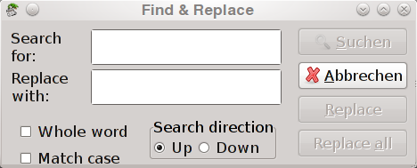Figure 4: Find & Replace dialog

Sorting
Pyspread dos not feature a sorting button, yet. However sorting can be achieved by defining a macro. A one-liner for sorting rows of column 0 in table 0 would be:
[S.__setitem__((i, 0, 0), repr(val)) for i, val in enumerate(reversed(sorted(S[:,0,0])))]

Working with formulas

Grid cells expect Python expressions
Python expressions are terms that Python evaluates to a result object. http://docs.python.org/reference/expressions.html gives an overview to the different types of Python expressions.
Pyspread expects such Python expressions in its grid cells. Therefore
1 + 1
is valid as is
[i ** 2 for i in xrange(100) if i % 3]
However, statements such as
print 2
or
import math
are not valid.

Variable assignment
Besides Python expressions, one variable assignment is accepted within a cell. The assignment consists of one variable name at the start followed by “=” and an Python expression. The variable is considered as global. Therefore, it is accessible from other cells.
For example
a = 5 + 3
assigns 8 to the global variable a.
Since only one assignment is possible,
b = c = 4
is not valid in a pyspread cell.
Note that evaluation order of cells is not guaranteed. Therefore, assigning a variable twice may result in unpredictable behavior of the spreadsheet.

Result strings in the grid
Cells that contain a Python expression display the string representation of the result object that is returned from this expression. The exception to this rule is the None object that displays an empty string i. e. an empty cell instead. All empty cells also return None so that an empty grid appears empty.

Absolute cell access
The result objects, for which string representations are displayed in the grid, can be accessed from other cells (and from macros as well) via the __getitem__ method of the grid, where the grid object is globally accessible via the name S. For example
S[3, 2, 1]
returns the result object from the cell in row 3, column 2, table 1. This type of access is called absolute because the targeted cell does not change when the code is copied to another cell similar to a call $A$1 in a common spreadsheet.
Absolute cell addresses can be inserted into cell code with <Ctrl> + <LeftClick> on a cell.
Note that each time that a cell calls another cell result, the called cell is re-evaluated. No dependency tracking of cells is done. Therefore, spreadsheets with many references to a single, slowly calculated cell may be slow. Freezing such a cell can significantly boost performance .

Relative cell access
In order to access a cell relative to the current cell position, 3 variables X, Y and Z are provided that point to the row, the column and the table of the calling cell. The values stay the same for called cells. Therefore,
S[X-1, Y+1, Z]
returns the result object of the cell that is in the same table two rows above and 1 column right of the current cell. This type of access is called relative because the targeted cell changes when the code is copied to another cell similar to a call A1 in a common spreadsheet.
Relative cell addresses can be inserted into cell code with <Shift> + <Ctrl> + <LeftClick> on a cell.

Slicing the grid
Cell access can refer to multiple cells by slicing similar to slicing a matrix in numpy. Therefore, a slice object is used in the __getitem__ call. For example
S[:3, 0, 0]
returns the first three rows of column 0 in table 0 and
S[1:4:2, :2, -1]
returns row 1 and 3 and column 0 and 1 of the last table of the grid.
The returned object is a numpy object array of the result objects. This object allows utilization of the numpy commands such as numpy.sum that address all array dimensions instead of only the outermost. For example
numpy.sum(S[1:10, 2:4, 0])
sums up the results of all cells from 1, 2, 0 to 9, 3, 0 instead of summing each row, which Pythons sum function does.
One disadvantage of this approach is that slicing results are not sparse as the grid itself and therefore consume memory for each cell. Therefore,
S[:, :, :]
will lock up or even crash pyspread with a memory error if the grid size is too large.

Frozen cells
In order to prevent cells from being evaluated, cells can be marked as frozen (flurry button on attribute toolbar). When this is done, the current cell code is evaluated and the result is stored in a cache. Instead of re-evaluating each time that another cell is updated, frozen cells always display the old, stored result.
The flurry button can only mark one cell at a time as frozen. The selection is ignored for this purpose. Only the cell at the cursor is frozen.
Frozen cells can be refreshed using the menu with View → Refresh Selected Cells or with <F5>. All selected cells are refreshed by this command.
Frozen cells can speed up spreadsheets with long running calculations. Furthermore, the number of callings of stateful functions can be controlled.
Note that while the frozen attribute is stored in the pys save-file, the frozen cell result cache is not.

Macros
Since cell evaluation order is not guaranteed in pyspread, macros can be used for modules that enforce state on importing. Furthermore, algorithms that are too complex for a single cell can be written as a macro.
Macros can be edited from within the macro editor via Macro → Macro list (Figure 5). The editor allows editing a text file that is executed when the spreadsheet is opened or when its content is updated.
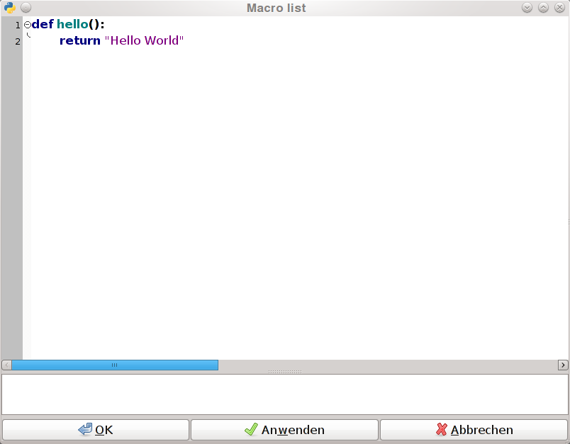Figure 5: Macro editor
The scope of macro execution is global. Therefore, all functions are directly accessible from each cell. For example, the function f that is displayed in Figure 5 can be called from a cell via f(). The result is the returned string “Hello World”.

Module import
Python modules cannot be imported with the import statement from within a cell because this statement is no Python expression. Therefore, module import from within a cell has to be realized by calling the function __import__:
<module_name> = __import__(“<module name>”)
This cell makes the module available from each other cell. Alternatively, a module can be imported as a macro with the import statement.
There are modules, which cannot be imported from within a cell. One example is rpy2 (rpy works well). The reason is that module initialization is stateful, i. e. certain statements have to be called in a specific order. Such modules can be used after initializing them with the macro editor.

Cyclic references
Cyclic references are possible again in version 0.2.0. However, recursion depth is limited. Pyspread shows an error when the maximum recursion is exceeded. Cyclic references are required for algorithms, in which cell objects are altered dynamically when cells are called. The drawback of allowing cyclic references is that complex cyclic calculations can lead to locking up pyspread.

Result stability
Result stability when redefining global variables cannot be guaranteed because execution order may be changed. This happens for when in large spreadsheets the result cache is full and cell results that are purged from the cache are re-evaluated.

Error handling
Cells that contain expressions that raise an error return this error.

Using help

Access to this document
This document can be displayed from within pyspread via the menu with Help → First Steps.

Python tutorial
With Help → Python tutorial, the Python tutorial is shown via the Internet. Note that a working Internet connection is required to access the Python tutorial.

Grid layout

Formatting basics

Fonts and font attributes

Text alignment, justification and rotation

Border and background color

Row height and column width

Insertion and deletion of rows and columns

pyspread and security

More than your average spreadsheet

Dangers of using pyspread

Security benefits and risks from save file signatures

Charts

Charts with matplotlib

Charts with rpy2

Charts with pychart

Advanced topics

Drawing cell content with a cell formula

Handling large amounts of data

Substituting pivot tables

